General Education Learning Assessment
Physical Education: Fitness For Life
2015-2016 Academic Year
Coordinator: Tim VanHaitsma

In 2015-2016, the General Education conducted an assessment in the Physical Education Department. In this assessment, students write and successfully implement an appropriate fitness program based on the training principles of frequency, intensity, and duration.

Direct Assessment
Design and Implementation
All students taking Fitness for Life are required to write an appropriate fitness program based on the training principles of frequency, intensity, and duration. We had 100% participation in this requirement. What is more difficult to measure is how successfully they can implement an appropriate fitness program based on the training principles of frequency, intensity, and duration. Therefore, a study was conduced to determine successful implementation of the fitness program, with a particular targeted focus on intensity.

Westmont College students who were enrolled in the Fitness for Life class (FFL) (n=307, 119 male, 184 female) were recruited for the study. Of the 307 students, 109 of the students were part of the control group that participated in the class in the Spring of 2015. The remaining 194 participated in the Heart rate monitor group in the Fall of 2015.

The purpose of this study was to compare the health benefit gains between using a self-report nine-week fitness plans (log card) and a nine-week online heart rate monitoring tool to monitor and record exercise. This study utilized three different exercise paradigms; a 12-minute run/walk, a push-up test, and a curl-up test. It was hypothesized that the use of the Polar heart rate monitor and the associated online exercise monitoring would increase the exercise performance outcomes.

Tools and methods
Participants
All procedures in this study were approved by the Westmont Institutional Review Board. Procedures were explained to all of the participants and all classroom procedures were unchanged for students in the class whether they chose to participate or not.

Experimental Protocol
All participants completed three different exercise tests near the beginning of the semester (end of week two and beginning of week three) and near the end of the semester (two weeks before the end of the semester, separated by 10-11 weeks). These exercise tests consisted of one cardiovascular endurance test and two muscular endurance tests.

Cardiovascular endurance was measured using the 12-minute run/walk as described by the American College of Sports Medicine (ACSM). This test can easily be done as a group and consists of each participant being directed to cover as much ground as possible on a synthetic track in 12 minutes. The test is measured to the nearest 1/8 of a lap.

Muscular endurance was measured using two different tests as described by ACSM. The first test measures the endurance of the chest and back muscles. The push-up test is administered with male participants beginning in the standard “down” position (hands pointed forward and under the shoulder, back straight, head up, using the toes as the pivot point) and females in the modified “knee push-up” position (legs together, lower leg in contact with the mat and ankles dorsi-flexed, back straight, arms shoulder width apart, head up, using the knees as the pivot point). The participant then raises the body by straightening the elbows before returning to the down position. Throughout the test, the back should remain straight and the score is measured as the maximal number of push-ups performed without rest.

The second muscular endurance test was the curl-up test. This test measures the muscular endurance of the abdominal muscles. The curl-up test is administered by having the participants lay on the ground touching a piece of tape. The participant then contracts their abdominal muscles raising their upper body off the ground to an angle of about 30 degrees above perpendicular, moving their hand along the ground until they touch a second piece of tape 10cm away. They then return their body to the ground. The participant moves at a rate of 40 beats per minute, performing 20 curl-ups every minute. The test ends when the participant is no longer able to maintain the cadence, is unable to continue, or reaches the maximum of 75 curl-ups.

9-week training program
Following the first set of exercise tests, each participant was asked to perform and record four exercise sessions per week for nine weeks. Each participant was asked to do a minimum of 3 cardiovascular workouts and one muscular strength workout per week. Both groups were asked to record all workouts on a log card which was checked by the instructor every 1-2 weeks.

The heart rate monitor group (HRM) was given an additional monitoring tool. They were asked to purchase the Polar H7 heart rate monitor (Polar Electro, Finland), which is able to pair with a Bluetooth enabled smartphone. The software is able to upload the information to an online coaching website (Polar Coach) which enables the instructor to observe and comment on each individual workout. Further, the Polar heart rate monitor allows the participant to determine and modulate workout intensity based on previous results.

Data Analysis
All statistics were performed using Excel/Statplus for Mac. To evaluate the effectiveness of the class in increasing physical fitness outcomes, paired t-tests were performed comparing the pre- and post-exercise 12-minute run/walk, push-up test, and curl-up test. In order to examine whether the heart rate monitor was effective in causing greater increases in fitness than the control group, equal variance t-tests were used to examine differences between groups. All data were presented as mean ± standard deviation, with significance set at an α < 0.05.

Results and Interpretation
12-minute Run/Walk Test
For the control group, the average distance run increased from 5.49±0.96 to 5.96±0.84 laps for a significant increase of 0.47±0.56 laps (p<0.001). The average distance run for the HRM group increased from an initial distance of 5.41±0.98 to 5.96±0.88 laps for a significant increase of 0.55±0.60 laps (p<0.001). When the increases between the control and HRM groups were examined, no difference was found between the groups (p > 0.05). Also, when the groups were split into those who took the class Pass/Fail and those who took the class graded, there were no differences between the groups (p < 0.05) as shown in Figure 1.
Figure 1
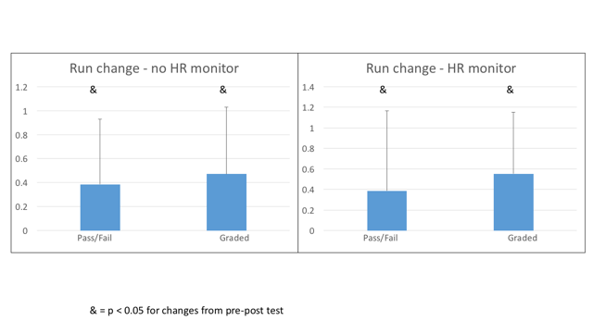
In summary as seen above in Figure 1, the Fitness for Life class resulted in an increase in cardiorespiratory fitness no matter if the students took the class with a pass/fail or graded option. Also, the addition of the heart rate monitor did not further increase the cardiorespiratory fitness of students in the class.

Push-up Test
For the control group, the average number of push-ups increased from 21.34±9.42 to 27.67±7.81 push-ups. This was a significant increase of 6.33±6.76 push-ups (p < 0.001). For the HRM group, the average number of push-ups increased from 18.74±10.26 to 28.19±8.38 push-ups for a significant increase of 9.45±8.09 push-ups (p < 0.001). When the increases between the control group and HRM group were compared, there were no differences found (p > 0.05). However, there were differences found in the HRM group when the pass/fail group was compared to the graded group, there was a significant difference between the groups (p < 0.05). This data can be found in Figure 2.
Figure 2
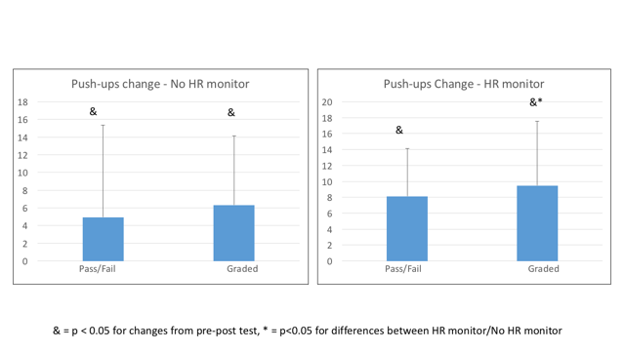

In summary as seen above in Figure 2, the Fitness for Life class resulted in an increase in muscular endurance fitness as evidenced by an increase in Push-up ability from the beginning of the semester until the end of the semester with no differences between students who took the class pass/fail or for a grade. Here, the heart rate monitor did result in additional increases in push-up ability in individuals who used the heart rate monitor and took the class for a grade as compared to traditional means of classroom administration.

Curl-up Test
For the control group, the average number of curl-ups increased from 50.96±18.57 to 68.39±9.79 curl-ups. This was a significant increase of 17.43±17.26 curl-ups (p <0.001). The HRM group increased from 51.28±21.72 to 66.57±16.32 curl-ups. This was also a significant increase of 15.28±19.35 curl-ups (p<0.001). There was no difference found between groups nor was there a difference found between those who took the class graded or pass/fail (p > 0.05) as is shown in Figure 3.

Figure 3
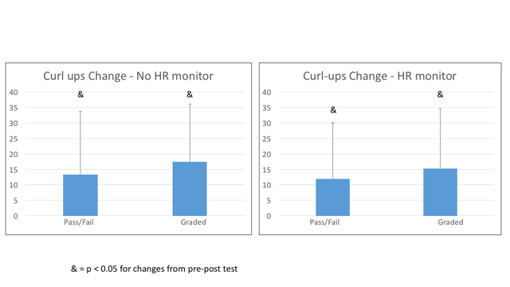
In summary as seen above in Figure 3, the Fitness for Life class resulted in an increase in muscular endurance fitness as evidenced by an increase in curl-up ability from the beginning of the semester until the end of the semester with no differences between students who took the class pass/fail or for a grade. Again, the heart rate monitor did not result in any additional increases as compared to traditional means of classroom administration.

Recommendations and Assessment
The purpose of the study was to determine if exercise outcomes were improved by using Polar heart rate monitors rather than just log cards. Unfortunately, heart rate monitors did not increase exercise outcomes more than the log cards. One thing that was apparent from this study is that the Fit for Life class was successful in significantly improving all measured exercise outcomes.

The log cards are good for measuring both frequency and duration of exercise. Where the log cards struggle, and previous methods struggle, is the measurement of intensity of exercise. The use of the heart rate monitors was supposed to allow increased measurement of intensity, but the class was not changed enough to allow us to utilize this increased measurement. However, teaching students to better utilize subjective measurements of intensity such as the “talk test” or the ratings of perceived exertion scale that have been validated may allow intensity measurement to continue in the future.

Throughout the semester, log cards enabled measurement of both frequency and duration of activity. The log cards allow easy determination on whether the required frequency and duration of exercise are met. However, the honesty of students is always an issue. The use of the heart rate monitors and associated online monitoring was a method that would allow further monitoring of workout frequency and duration. However, because the exercise outcomes were not improved, the added cost of the heart rate monitors was not deemed appropriate.

Benchmark
As a benchmark, students should be able to meet the 50% fitness category as defined by ACSM in 2011. To do this, males need to be able to run 1.53 miles, or 6.12 laps whereas females need to run 1.37 miles or 5.48 laps. Over the last several years, our students were able to meet this benchmark, with males running 6.7 (Fall 2015) and 6.5 (Spring 2015) laps in the last two years and females running 5.6 (Fall 2015) and 5.5 (Spring 2015) laps in the last two years. These marks would put men in the 75th percentile and women in the 60th percentile.

Closing the loop
Fitness for Life or similar programs are required in many colleges across the country. We are all asking the same questions. How can we motivate students to exercise at an appropriate frequency, intensity and duration to produce needed health benefits? As a result, this study was presented by Dr. Tim VanHaitsma this June at the Christian Society for Kinesiology and Leisure Studies national conference held at Westmont College June 8-10.

One of the big questions in our department is whether Fitness for Life program improves exercise outcomes. This study demonstrated that health outcomes were greatly improved over the course of the class. One of the primary health outcomes that is associated with longevity and reduced mortality is cardiovascular endurance. This was measured by the 12-minute run/walk test during our study. This study determined that there was a 10% increase in cardiovascular endurance, suggesting that there is a decreased chance of mortality, a decreased risk of coronary heart disease, and an increased protection from non-cardiac diseases such as non-insulin-dependent (Type II) diabetes, hypertension, and several other diseases. This data suggests that the FFL class is effective at teaching and implementing basic exercise training principles. Therefore, the basic requirements of the class will not be changed.

However, the heart rate monitor was not effective in further increasing fitness outcomes over log cards alone and will no longer be used in the class. As a Kinesiology group, we will continue to innovate within the Fitness for Life class in order to ensure increased knowledge and increased exercise outcomes in the enrolled students. We would like to try both a psycho-social motivational approach and the use of pedometers to improve motivation in the future.

Timeline
The fall Fitness for Life classes will not be using heart rate monitors. In its place, the classes will be required to purchase and use a pedometer to measure daily steps. In addition, students in all fall classes will be assigned a workout partner to increase motivation to achieve the desired frequency, intensity and duration of workouts.

Conclusion
We are satisfied with the current Physical Education GELO and area description.

